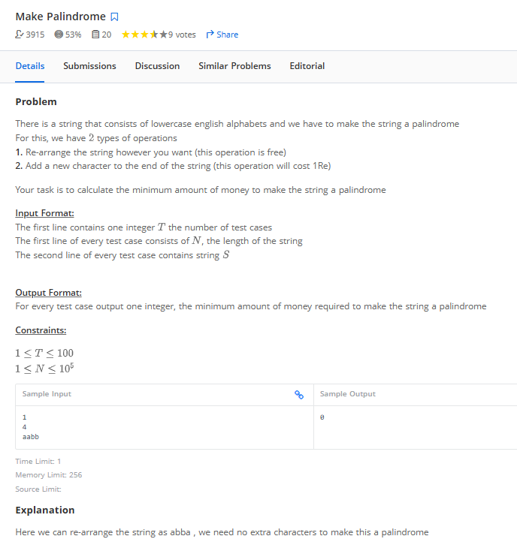

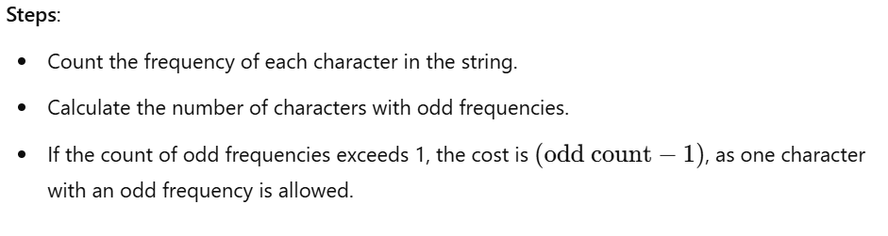

----------- Ans
for i in range(int(input())):
N = int(input())
input_str = input().strip()

freq = {}
# freq count of each char in str
for char in input_str:
if char not in freq:
freq[char] = 1
else:
freq[char] += 1
#print(freq)

# count odd freq
odd_cnt = sum(1 for i in freq.values() if i%2 != 0)
#print(odd_cnt)

# min cost = max(0,odd_cnt-1)
min_cost = max(0,odd_cnt-1)

print(min_cost)

